

**How to Connect Android Studio to GitHub**

1. Introduction
2. You start by creating an profile on GitHub.com. By the end of these instructions, you will have successfully connected an Android Studio project with GitHub. GitHub is used to share code with others who are working on the same project so everyone has access to everyone’s changes. This makes collaborating much easier because all of the code for the project is shared in one place.

These instructions will **NOT** teach you how to:

* Install Android Studio
* Build a project in Android Studio

1. Definitions:
   1. Collaborate -(Collaborators) Work with other people to produce a certain project
   2. Commit - takes files that you have made changes to, and prepares them to be added to your GitHub repository
   3. Git - a widely used version control system (VCS) for software development, which holds a repository
   4. GitHub - a web-based Git repository hosting service
   5. IDE - Integrated Development Environment; software application that provides comprehensive facilities to computer programmers for software development
   6. Pull - updates the files on your local machine with any changes that are on GitHub that your files do not have
   7. Push - collects all your files that have been committed and sends them to GitHub
   8. Repository - a file on GitHub that stores all your code, and contains a historical record of changes since the start

**Note**:You can create more than one and each repository holds its own project. Public repositories are open for anyone to look at. Private repositories can only be accessed by you and those whom you allow to access the content.

* 1. Version Control System (VCS) - 3rd party application or program that holds the main project for you. Allows easy sharing of the project between multiple people

1. List of Materials

* A computer
* Android Studio installed (**Note:** if not installed, follow this installation guide at http://developer.android.com/sdk/index.html)
* Internet connection
* An already existing Android Studio project. (**Note:** If you do not know how, follow how to build an android project at https://developer.android.com/training/basics/firstapp/index.html)

1. Directions
2. Setting up GitHub
   1. Go to github.com
   2. Type in a unique username and password, and your email address. Then, click on the “Sign up for GitHub” button to create an account with GitHub.

**Warning**: choose a username and password you can easily remember or write them down for use in step 2.4.

* 1. A welcome screen, as seen in Figure 1, will pop up with a table of different GitHub repository options. The default choice is the “Free” option with zero Private Repos (repositories). Do not change this option, and click on “Finish Sign Up”.

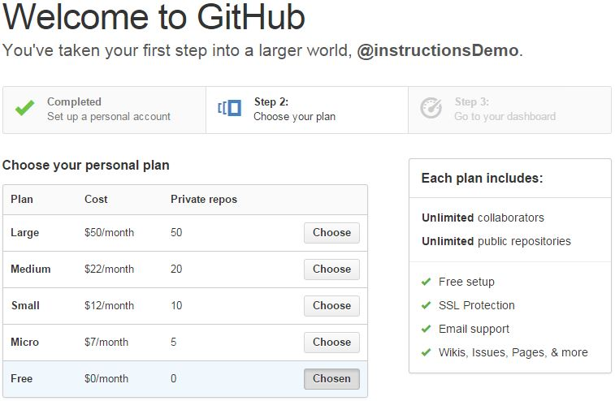

*Figure 1*

*Welcome screen with prices for github.com (Source: https://github.com/join/plan)*

* 1. As a result of finishing the last step, your web browser will take you to your newly created GitHub account page’s email tab. You can add new emails addresses to your account, and then hit the “Send Verification Email” button as seen in Figure 2.

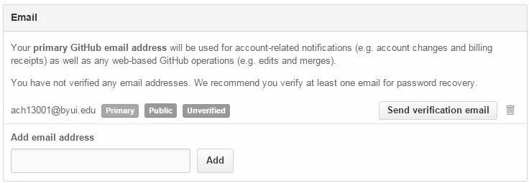

*Figure 2*

*Email Verification Screen on GitHub (Source: https://github.com/settings/emails)*

* 1. Go to the inbox of the email address you provided, and open the email with the subject “[GitHub] Please verify your email '<your email address>' ” as seen in Figure 3. Click on the link provided to verify your email address.

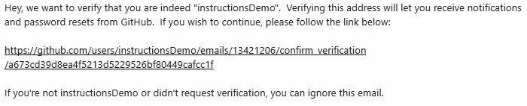

*Figure 3*

*Verification Email sent to your inbox (Source: https://outlook.office365.com)*

* 1. You will then be asked to sign in again to GitHub, and hit the “Confirm” button to finish verifying your email address.

**Note:** You will then have the option to add any other email addresses. If you do not want to add any more, you are done with setting up your GitHub account.

* 1. If you return to the home screen (either by selecting the GitHub icon in the top left corner or going straight to your account at github.com/yourUserName), your web browser will bring you to the GitHub homepage, giving you options to create and share repositories, as seen in Figure 4. This is useful if not using an IDE like Android Studio to create the repository. Instead of building the repository directly on GitHub, we will use Android Studio to do this for us.

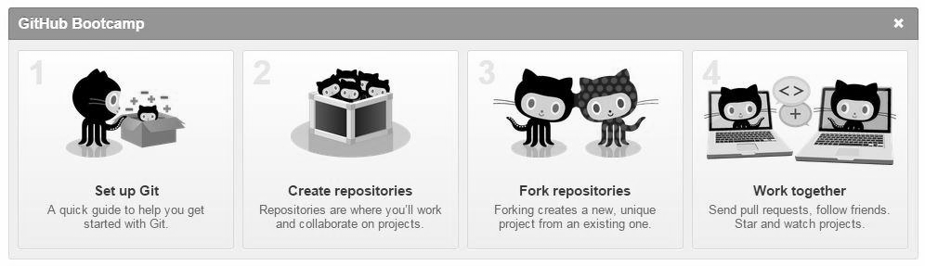

*Figure 4*

*Options at homepage (Source:* [*https://github.com/*](https://github.com/)*)*

1. Connecting an Android Studio project to GitHub
   1. Open the Android Studio project you desire to put onto GitHub.
   2. At the top of the project screen, click on VCS (Version Control System) tab.
   3. Near the bottom of the drop down tab of VCS, click on “Import Into Version Control”.
   4. To the right, click “Share Project on GitHub”.

The first time you do choose this option, a dialog box will pop up, asking for your GitHub login information that you created earlier in this instructions. See Figure 5. Fill in the information and click “Login”.

**Warning:** If you get a dialog box looking like Figure 6, see Troubleshooting 1.

*Figure 5 Figure 6*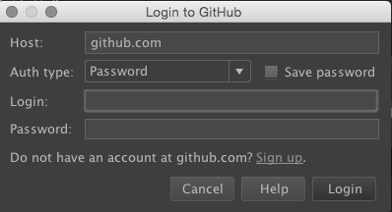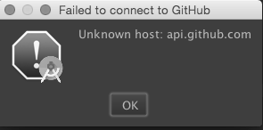

*GitHub login from Android Studio Failed GitHub Connection*

*(Source: Android Studio) (Source: Android Studio)*

* 1. A dialog box looking like Figure 7 should appear. This dialog box contains an area for the name of the GitHub Repository and an optional description. The “New repository name” field will already be filled in with the name of the project (**Note**: if you desire a new name, you may change it, but names can only contain letters, dashes, numbers, dots and underscores). The description field asks for a short description of what will be in the repository so those you share the project with will understand what the project involves.

*Figure 7* 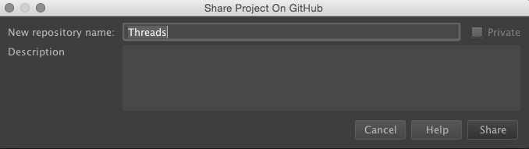

*Dialog box for Sharing project (Source: Screenshot from Android Studio)*

* 1. Select “Share”
  2. A screen will appear displaying all of the files to “push” onto GitHub. Select “OK”.

**Note:** You can choose to omit files you do not wish to share on GitHub by unselecting them.

1. Pushing and Pulling from GitHub
   1. After you have worked on your project, go to VCS, and hit the “Commit” button with a green arrow next to it.
   2. A screen will pop up with a list of files that have been changed, and a text box with the caption “Commit Message”. Give a brief description of what you’ve changed, and hit the blue “Commit” button.
   3. A text box may pop up asking if you want to commit. See Figure 8. Click on “Commit”.

**Note:**  It will list a number of errors and warnings that exist in the code, but you can still commit. By clicking on review, Android Studio will take you to any errors or warnings that may exist within your code.

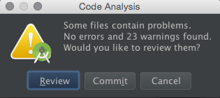

*Figure 8*

*Committing files to GitHub (Source: Screenshot from Android Studio)*

* 1. Go to the VCS tab, the “Git” menu about halfway down, and select “Push”. This will push your changes to GitHub.

4. Troubleshooting

1. If you are unable to connect to the Github, check your Internet connections. If the problem persists, restart Android Studio.
2. If Figure 9 appears in the upper right hand corner, the current project has already been shared on GitHub under any account (**Note:** “any” meaning even someone else’s account). Create a new project and transfer all needed files into the new project.Screen Shot 2015-03-09 at 2.14.37 PM.png

*Figure 9*

*Project already on Github (Source: Screenshot from Android Studio)*

1. If you type in a URL that does not exist, like “github.com/userName” with your username misspelled, you’ll get a 404 Error, and a screen like Figure 10 will pop up. Either check your URL, or use GitHub’s provided search bar where you can type in a user name or repository name to search for.

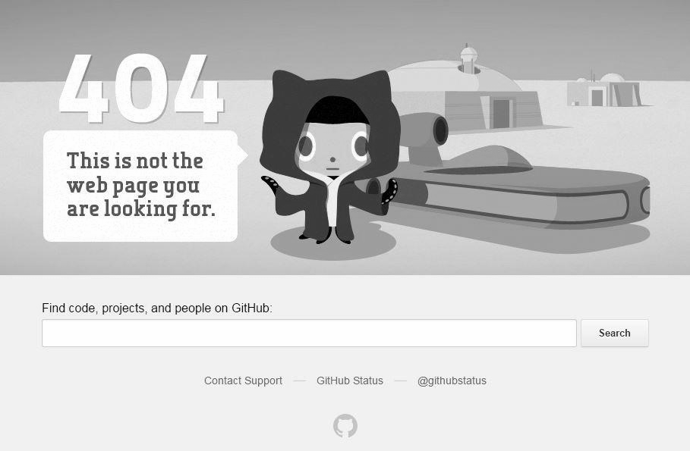

*Figure 10*

*github 404 Error: Page Not Found (Source: https://github.com/<invalid_file_path>)*